2019 GI (嘉長 陳妙芬 HCC / Esophagus)
- BCLC stage
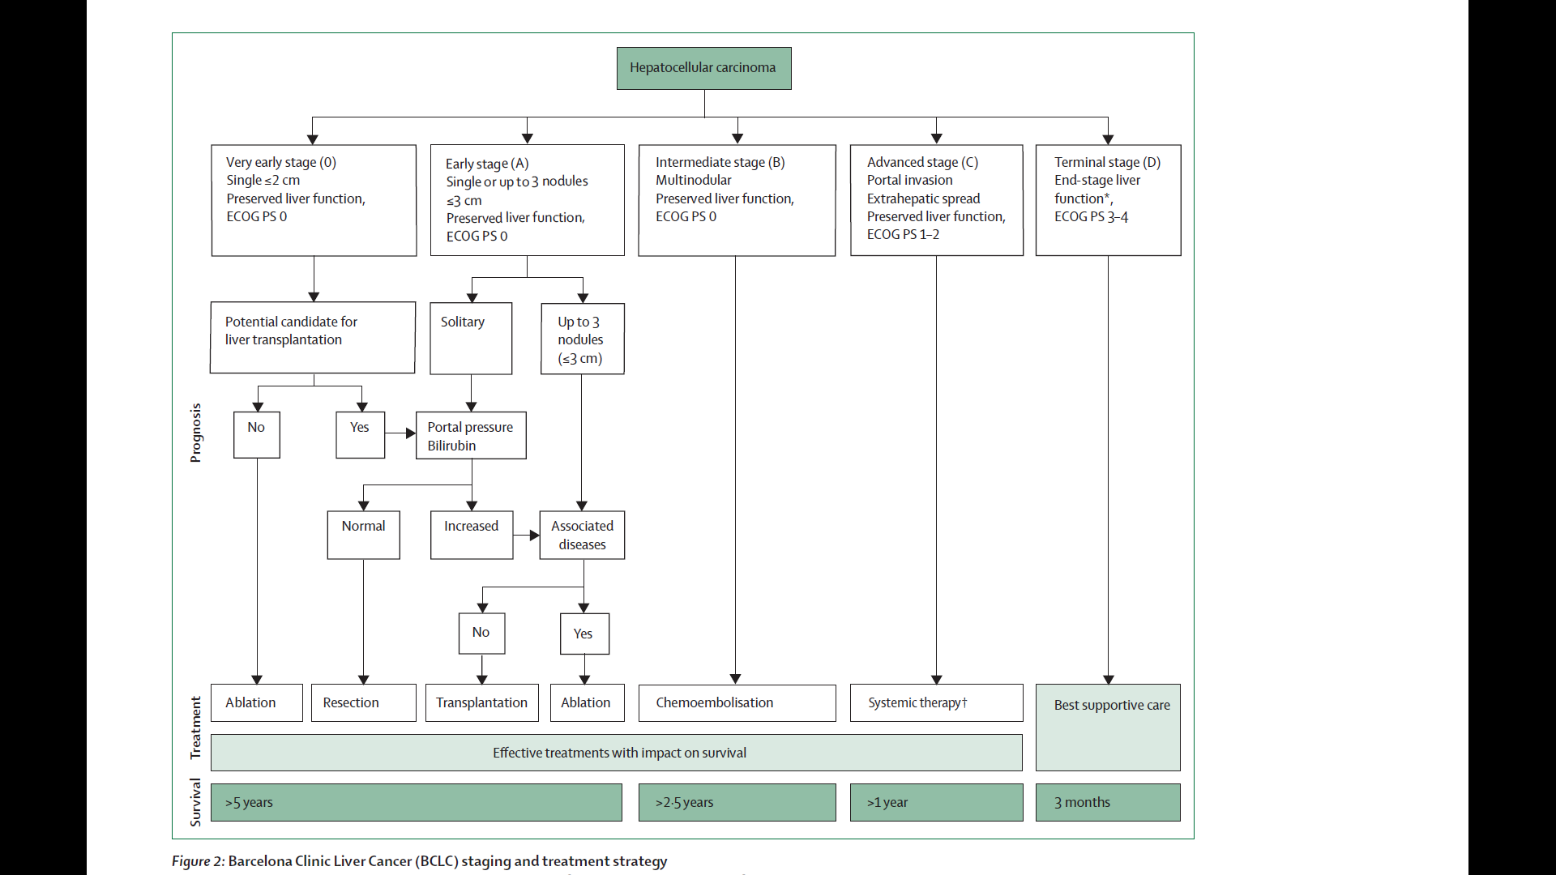

- Child Pugh score
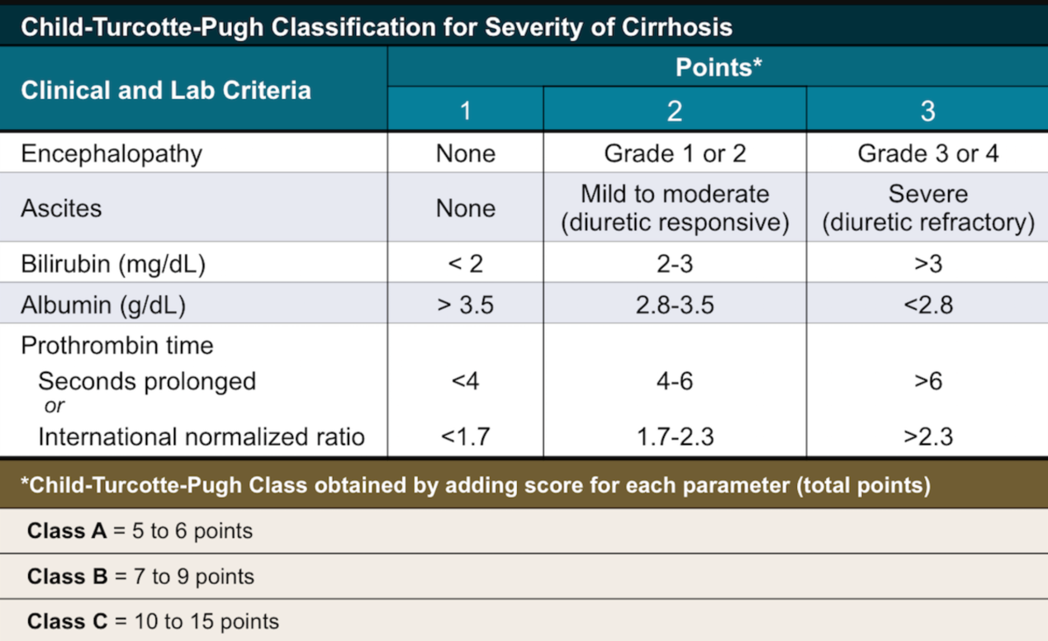
- SBRT indication and dose

Indication:
<2021.4 NCCN>
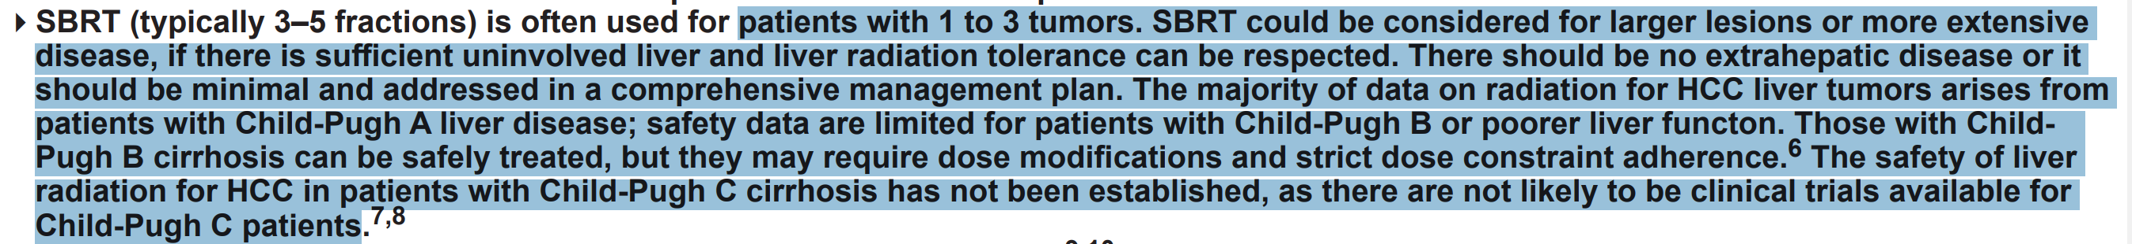
- 1-3顆 + Child A/B + 腫瘤大小沒有絕對限制(看univolved liver)
<健保支付標準>
- 原發性肝膽單一病灶(可為原發性肝癌或肝內膽道癌)
- 肝功能為Child-Pugh A至B級，ECOG status ≤2 (或KPS≥70)
- 病灶最大徑≤5公分
- 經評估無法進行下列之一的治療或下列之一的治療失敗者
A.手術切除 B.血管栓塞治療 C.電燒灼治療

Dose: (不太一致，Perez/NCCN參考)
Perez: 24-60 Gy in 3-10 fr
NCCN: 30-50 Gy in 3-5 fr

- 你們醫院liver radiation做最多的是哪種case?
PVT 劑量 / constraint (conventional RT and SBRT) / response rate

Convention RT
劑量: 45Gy in 1.8Gy and boost to 50-60Gy <by NCCN>
Response rate: Range蠻大，附上PEREZ Table 64.3
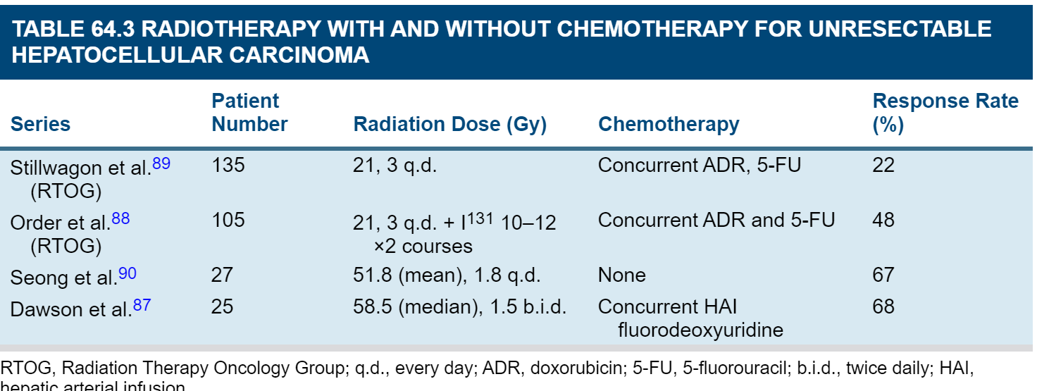
Constraint:
Perez: Dmean <23Gy
Handbook of evidence-based: Dmean <28Gy (minus GTV)

SBRT
劑量
Perez: 24-60 Gy in 3-10 fr
NCCN: 30-50 Gy in 3-5 fr
Response rate:
2-3年的local control rate :70-90%，其中CR rate <20% (by Perez)
Constraint:
Perez:
1.At least 800 mL of normal liver should receive no more than 18 Gy
2.32 to 34 Gy in 6 fractions to the stomach, duodenum, and small bowel and 12 Gy to the kidney
Handbook of evidence-based:
1.>700ml normal liver should < 15Gy in 3-5fr
2.Liver mean dose < 13Gy/3fr, <18Gy/6fr, <6Gy

- 治療HCC的病人有沒有遇過RILD, 比率多少? Classic and Nonclassical?

發生比率:
每個paper寫不太一樣，1-3成都有寫到 (而且還要看病人的狀況及RT技術決定)
Classic | Non classic
健康肝 | 有潛在肝病
occlusion and obliteration  hepatocyte necrosis | Poor liver function  decline in liver function
腹水 / 2倍 ALP | 黃疸 / 5倍 GOT GPT

- RFA indication?

Perez:
- Not meet resectability criteria for HCC and yet are candidates for a liver-directed procedure based on the presence of liver-only disease.
- The best outcomes are in patients with a single tumor >2 and <4 cm in diameter.
NCCN:
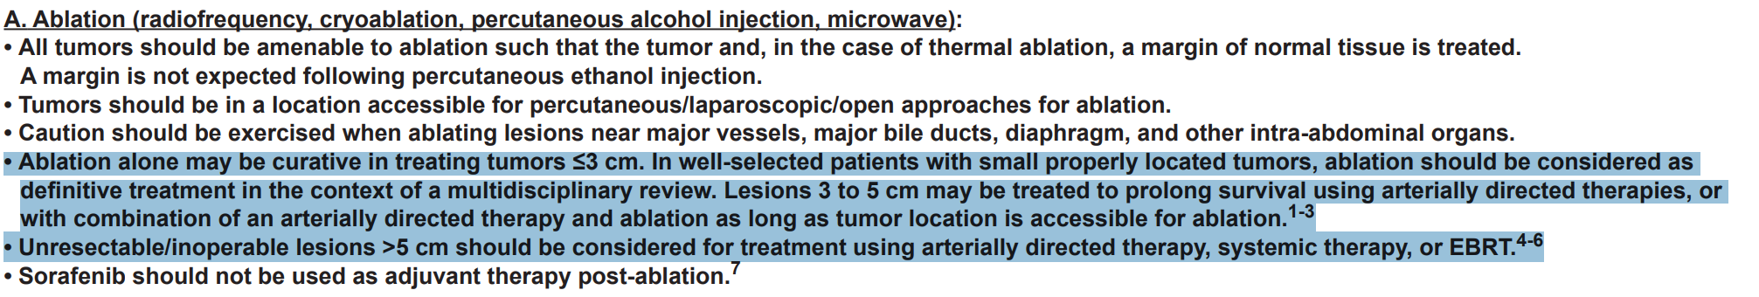

- T3N1M0 esophageal cancer治療, RT dose/field, 要不要做ENI, 怎麼評估能不能開刀, 若不開刀boost dose

RT field and dose:
GTVp上下加4 cm，旁邊加1 cm;
GTVn +1cm
CTV+ 0.5-1cm =PTV
5040cGy/28fr + C/T with PF (per CALGB 9781)

ENI (by NCCN)
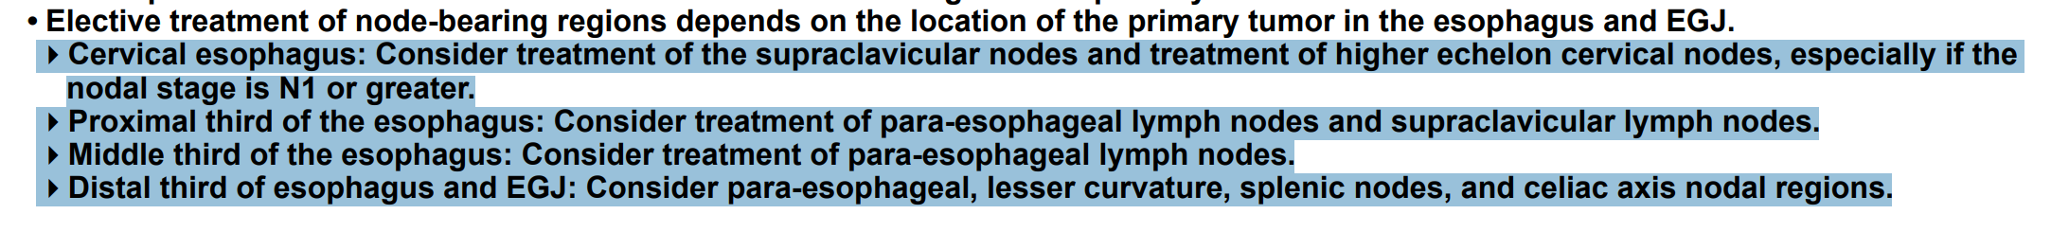

評估開刀 (by NCCN)
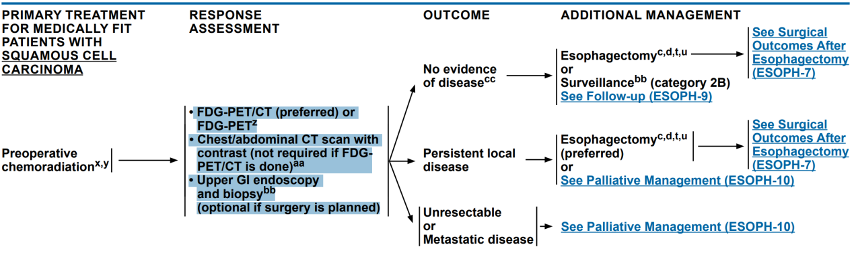
不開刀boost dose ??
不太知道要問 有residual要boost還是一開始就要boost

RTOG 8501 / INT 0123 / ARTDECO Study EBM: escalation 沒有benefit
NCCN: 41.4Gy-50.4Gy (cervical esophageal cancer可以提高至54-66Gy if surgery not planned)

2019 GI (高醫 黃旼儀 Rectal/Anal)
- Rectal 給臨床資訊，問後續檢查治療安排
沒有臨床資訊…

- Anal cancer case, stage, 治療策略

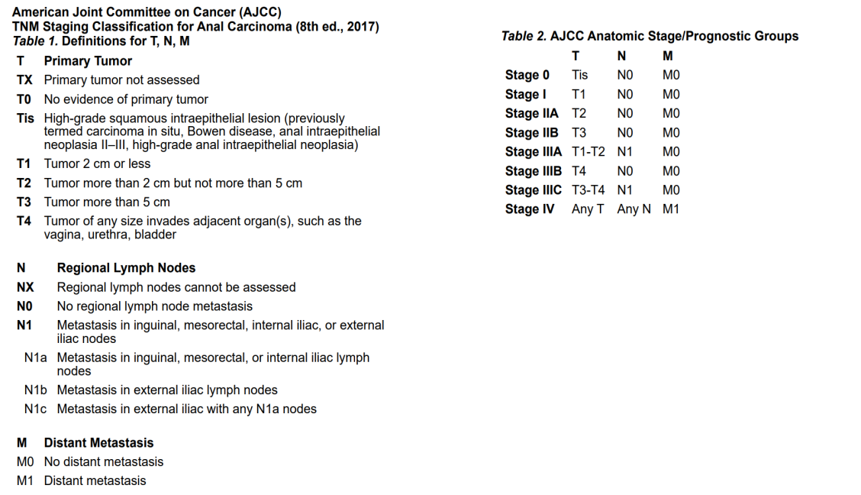
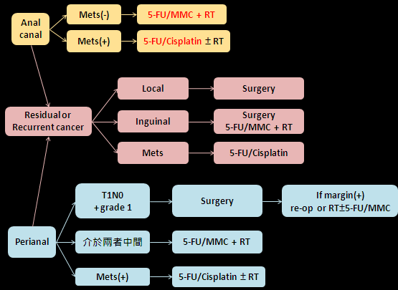
- Rt & Lt colon ca 差異 (Symptom, patho, molecular, incidence, treatment)
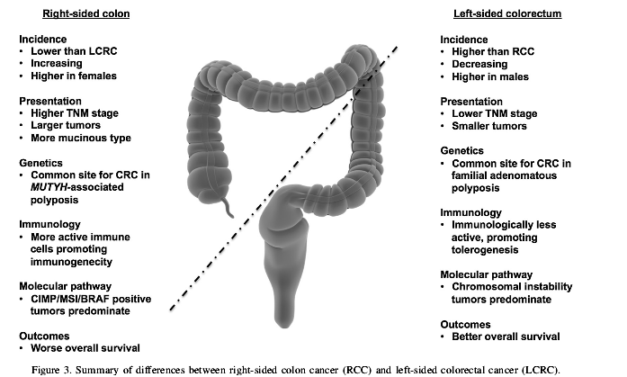
Ref: 2014 European Journal of Surgical Oncology (EJSO)
<有跟出題者確認只是要考左右結腸的基本差異>

- 有沒有做過gastric cancer

RT indication:
1) Inoperable -> 可以CCRT
2) R1 or R2 resection
3) T3 or N1開完刀但是沒有開D2就要做adjuvant CCRT

